Studia Islamika 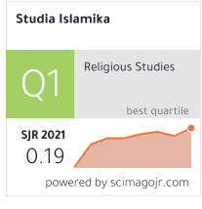

https://journal.uinjkt.ac.id/index.php/studia-islamika

Journal of Islamic Ethics

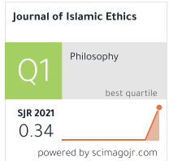

https://www.scimagojr.com/journalsearch.php?q=21101041535&tip=sid&clean=0

Islam - Zeitschrift fur Geschichte und Kultur des Islamischen Orients

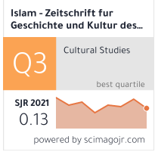

Should you have institutional access?Here's how to get it ...

INDONESIAN JOURNAL OF ISLAM AND MUSLIM SOCIETIES

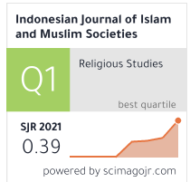

https://ijims.iainsalatiga.ac.id/index.php/ijims/

INTERNATIONAL JOURNAL OF ISLAMIC THOUGHT

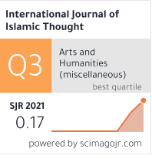

https://www.scimagojr.com/journalsearch.php?q=21100944566&tip=sid&clean=0

AFKAR-JURNAL AKIDAH & PEMIKIRAN ISLAM-JOURNAL OF AQIDAH & ISLAMIC THOUGHT

https://www.scimagojr.com/journalsearch.php?q=21100944566&tip=sid&clean=0

International Journal of Islamic Architecture
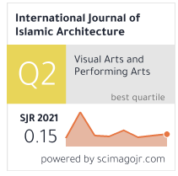
https://www.intellectbooks.com/international-journal-of-islamic-architecture

ISLAM AND CHRISTIAN-MUSLIM RELATIONS
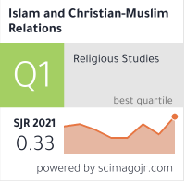
https://www.scimagojr.com/journalsearch.php?q=200147137&tip=sid&clean=0

ISLAMIC AFRICA
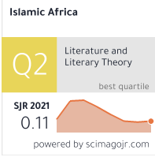
https://www.scimagojr.com/journalsearch.php?q=21100785521&tip=sid&clean=0

ISLAMIC LAW AND SOCIETY
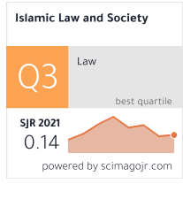
https://www.scimagojr.com/journalsearch.php?q=5700160560&tip=sid&clean=0

JOURNAL OF ISLAMIC ARCHAEOLOGY
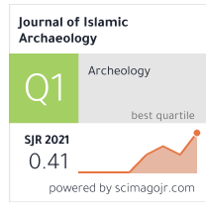
https://www.scimagojr.com/journalsearch.php?q=21100854799&tip=sid&clean=0

Journal of Islamic Manuscripts
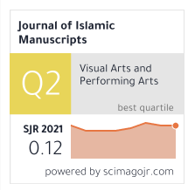
https://www.scimagojr.com/journalsearch.php?q=21100403909&tip=sid&clean=0

Journal of Islamic Studies
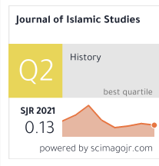
https://www.scimagojr.com/journalsearch.php?q=5600153217&tip=sid&clean=0

Indonesian Journal of Islam and Muslim Societies
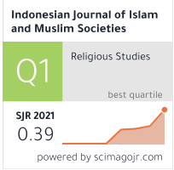
https://www.scimagojr.com/journalsearch.php?q=21100843365&tip=sid&clean=0

Journal of Shi'a Islamic Studies
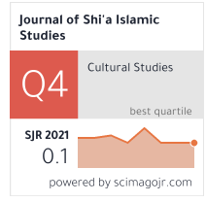
https://www.scimagojr.com/journalsearch.php?q=19700170140&tip=sid&clean=0

Qudus International Journal of Islamic Studies
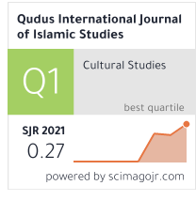
https://www.scimagojr.com/journalsearch.php?q=21100889414&tip=sid&clean=0

Osmanli Arastirmalari - Journal of Ottoman Studies
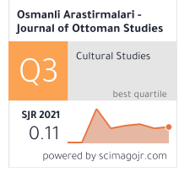
https://www.scimagojr.com/journalsearch.php?q=21100423330&tip=sid&clean=0

Journal of Al-Tamaddun
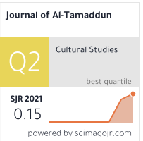
https://www.scimagojr.com/journalsearch.php?q=21100927901&tip=sid&clean=0

Die Welt des Islams
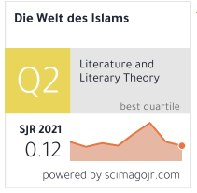
https://www.scimagojr.com/journalsearch.php?q=5700164244&tip=sid&clean=0

ISRA International Journal of Islamic Finance

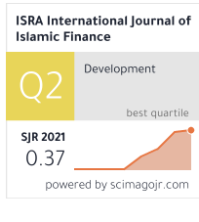
https://www.scimagojr.com/journalsearch.php?q=21100870829&tip=sid&clean=0

Ilahiyat Studies
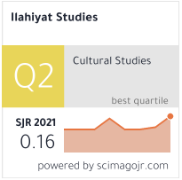
https://www.scimagojr.com/journalsearch.php?q=21100322429&tip=sid&clean=0

International Journal of Islamic Thought
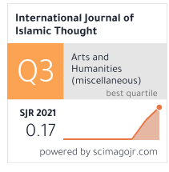
https://www.scimagojr.com/journalsearch.php?q=21100944566&tip=sid&clean=0

Journal of Sciences, Islamic Republic of Iran
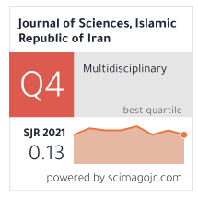
https://www.scimagojr.com/journalsearch.php?q=19900191882&tip=sid&clean=0

Al-Qantara
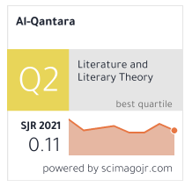
https://www.scimagojr.com/journalsearch.php?q=22229&tip=sid&clean=0

Global Journal Al-Thaqafah

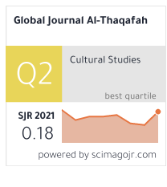
https://www.scimagojr.com/journalsearch.php?q=21100324067&tip=sid&clean=0

Cumhuriyet Ilahiyat Dergisi
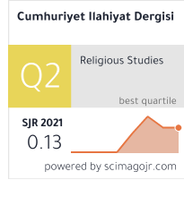
https://www.scimagojr.com/journalsearch.php?q=21100857857&tip=sid&clean=0

Darulfunun Ilahiyat

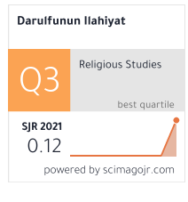
https://www.scimagojr.com/journalsearch.php?q=21101058362&tip=sid&clean=0

Ankara Universitesi Ilahiyat Fakultesi Dergisi

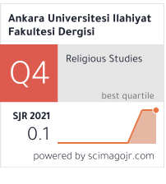
https://www.scimagojr.com/journalsearch.php?q=21100967846&tip=sid&clean=0

Intellectual Discourse
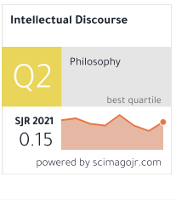
https://www.scimagojr.com/journalsearch.php?q=5600156881&tip=sid&clean=0

Journal of Al-Tamaddun
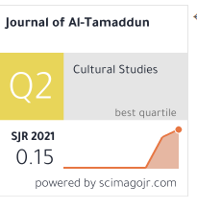
https://www.scimagojr.com/journalsearch.php?q=21100927901&tip=sid&clean=0

AL-SHAJARAH
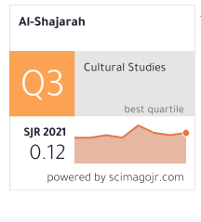https://www.scimagojr.com/journalsearch.php?q=21100218383&tip=sid&clean=0

RELIGIOUS INQUIRIES
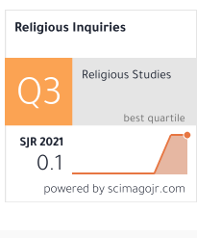https://www.scimagojr.com/journalsearch.php?q=21100970263&tip=sid&clean=0

Islamic Law and Society
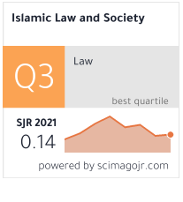https://www.scimagojr.com/journalsearch.php?q=5700160560&tip=sid&clean=0

Journal of Islamic Thought and Civilization
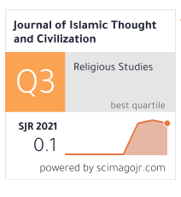
https://www.scimagojr.com/journalsearch.php?q=21100933831&tip=sid&clean=0

International Journal of Islamic Thought
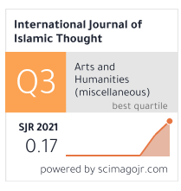
https://www.scimagojr.com/journalsearch.php?q=21100944566&tip=sid&clean=0

Hamdard Islamicus
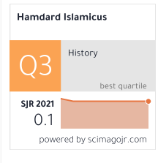
https://www.scimagojr.com/journalsearch.php?q=21100211306&tip=sid&clean=0

Islamic Quarterly
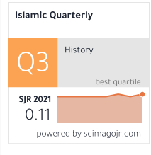https://www.scimagojr.com/journalsearch.php?q=21100241607&tip=sid&clean=0

Samarah
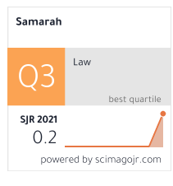https://www.scimagojr.com/journalsearch.php?q=21101045325&tip=sid&clean=0

Al-Shajarah
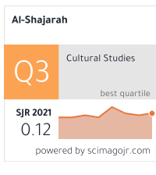https://www.scimagojr.com/journalsearch.php?q=21100218383&tip=sid&clean=0

Al-Jami'ah
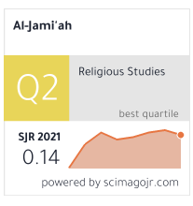
https://www.scimagojr.com/journalsearch.php?q=21100322122&tip=sid&clean=0

Indonesian Journal of Islam and Muslim Societies
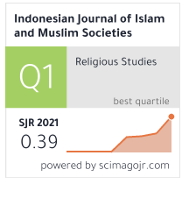
https://www.scimagojr.com/journalsearch.php?q=21100843365&tip=sid&clean=0

Islamic History and Civilization
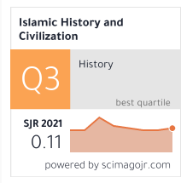
https://www.scimagojr.com/journalsearch.php?q=21100407919&tip=sid&clean=0

Studia Islamica
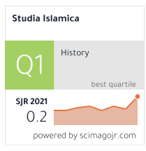
https://www.scimagojr.com/journalsearch.php?q=14098&tip=sid&clean=0

Islam - Zeitschrift fur Geschichte und Kultur des Islamischen Orients
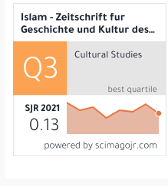https://www.scimagojr.com/journalsearch.php?q=16200154787&tip=sid&clean=0

Islam and Christian-Muslim Relations
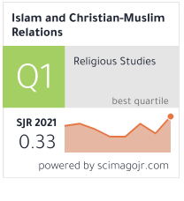
https://www.scimagojr.com/journalsearch.php?q=200147137&tip=sid&clean=0

Contemporary Islam
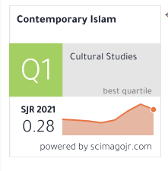

https://www.scimagojr.com/journalsearch.php?q=6700153290&tip=sid&clean=0

